Your Name:

Today’s Date:

Please submit the package back to the supervising teacher before you leave.
THANK YOU!

MISS YOU ALL AND SEE YOU SOON!

Dr. Liu

________________________________________________________________

SECTION 1: Chinese Culture and Traditions
1. Watch the video on the introduction of Chinese culture and traditions
Use the notes area in the package to write down (could be bullet points):
1. Three things that you learned from the video.
2. Two things that would like to know more.
3. One question you have.

VIDEO 1:
- The hidden meanings of yin and yang - John Bellaimey
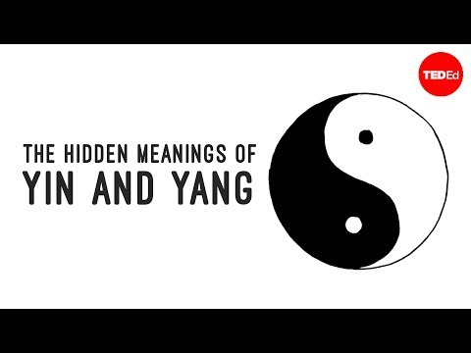

1. Three things that you have learned from the video.

2. Two things that would like to know more.

3. One question you have.

VIDEO 2:
The deadly irony of gunpowder - Eric Rosado
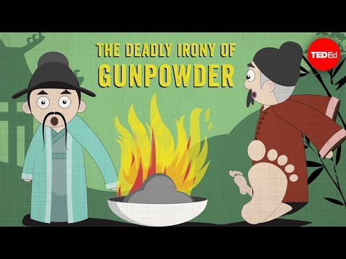

1. Three things that you have learned from the video.

2. Two things that would like to know more.

3. One question you have.

SECTION 2. CHINA DAILY REVIEW
Go to www.chinadaily.com.cn.
2. Search on the website the current events about China, Asia, and the World.
3. Write in the package 3 pieces of news that you are interested in areas of politics, economy, culture, sports, etc. Write about in a few sentences
1). What is it?
2) Why is it important to know?

News 1:

News 2:

News 3:

