Lesson 1 Project: Designing A New Delaware mall
(due 9/23)

Requirements:
- Present the mall to class in any way that you prefer, for example, PPT slides, video, paper drawing, or computer graphs
- Presentation: about 3 minutes
- Present it only in Chinese - LOOK FOR LANGUAGE HELP FROM YOUR PARENTS OR FRIENDS, OR DICTIONARY!
- Use as much language possible they have learned in previous years and in our current lessons.
- Be creative and have fun!

Content to include:
- Name of the mall
- The overall layout and different parts of the mall
- Exciting features of the mall

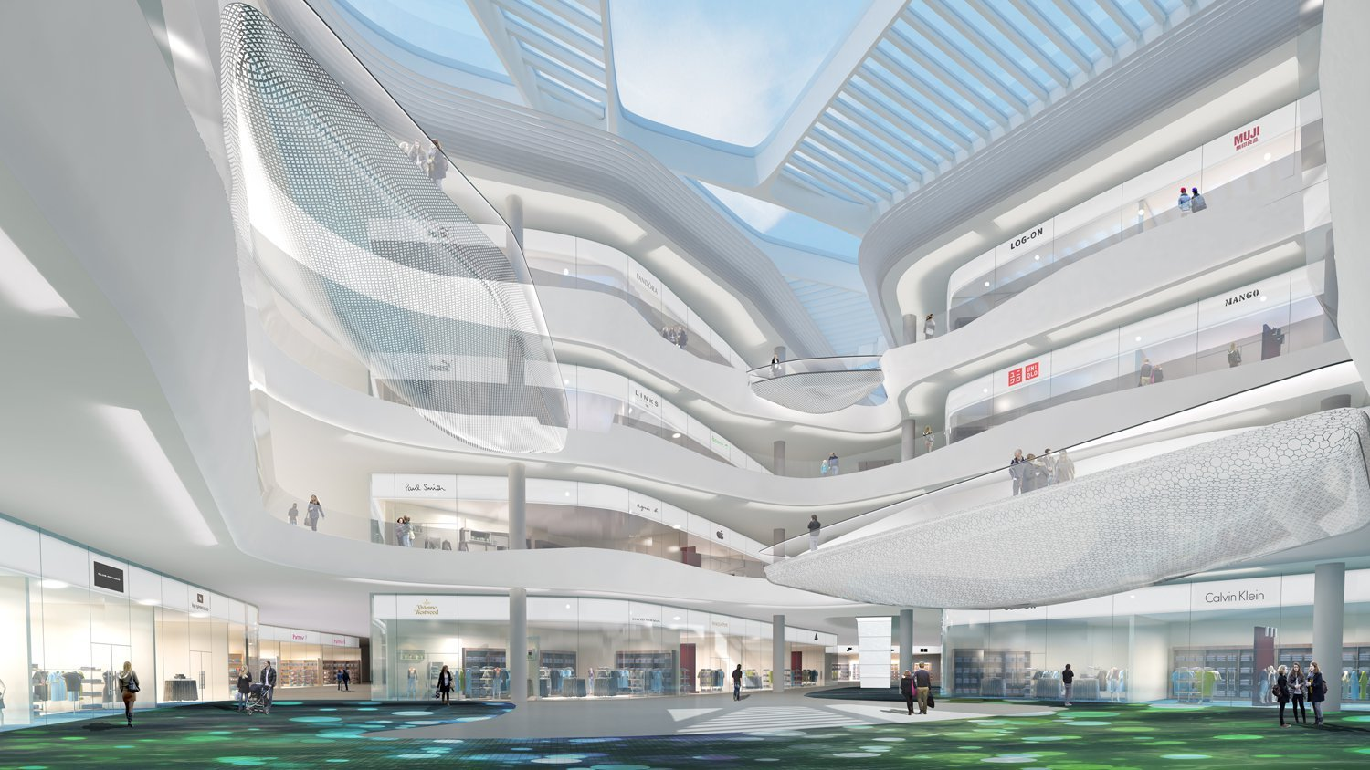

You could choose to present on one of the two days
9/23 and 9/30
Share with me your presentation via google doc ahead of time if you choose to use PPT or video format.

语言参考: ( some examples but not limited to all following)
词汇：
- 百货公司
- 购物中心
- 皮包点
- 鞋店
- 专卖店
- 电扶梯
- 试衣间
- 服装店
- 玩具店
- 化妆品专柜
- 紧急出口
- 珠宝店
- 小吃街
- 宽广的休闲区
- 梅西百货公司
- 折扣区

句型：
- …商场是特拉华州最大最好的购物中心。
- 它包括… 个大的宝货公司和…家不同的专卖店
- 百货公司里有…
- 很多商店都标示了不同的折扣
…
