Scavenger Hunt in Chinatown

Take a picture in front of the
Friendship Gate (or called China Gate)
 | Take a picture of a Chinese bakery Cafe | 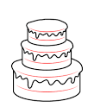
 | Find Roasted Ducks | 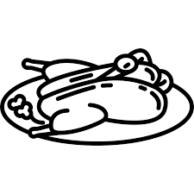
 | Find a Chinese church or temple
 | Say Ni Hao to a Chinese speaker
 | Collect a pair of chopsticks from a restaurant | 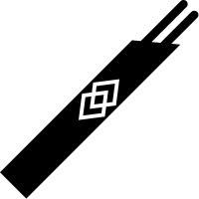
 | Find a noodle restaurant | 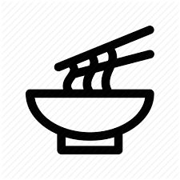
 | Collect a Chinese restaurant menu
 | Find Chinese Culture and Community Center
 | Find a Chinese Dim Sum restaurant (China Southern Style)
 | Find a statue (e.g. terra cotta solider or lion or others) | 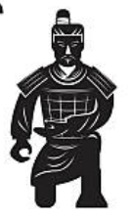  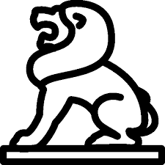
 | Find one of any other Asian restaurant in Chinatown  (Burmese, Japanese, Korean and Vietnamese) | 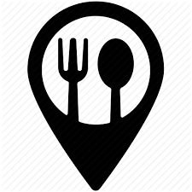
 | Find a Chinese Supermarket

Draw or write three things you have never seen before:

Draw or write one new food item that you tried in Chinatown:

