中文七考试 – 数字
名字：

- Fill in the hundred chart in Chinese (1 point each, 54 points in total)

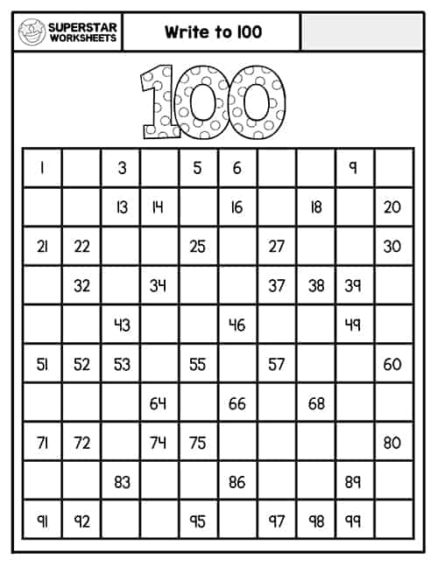

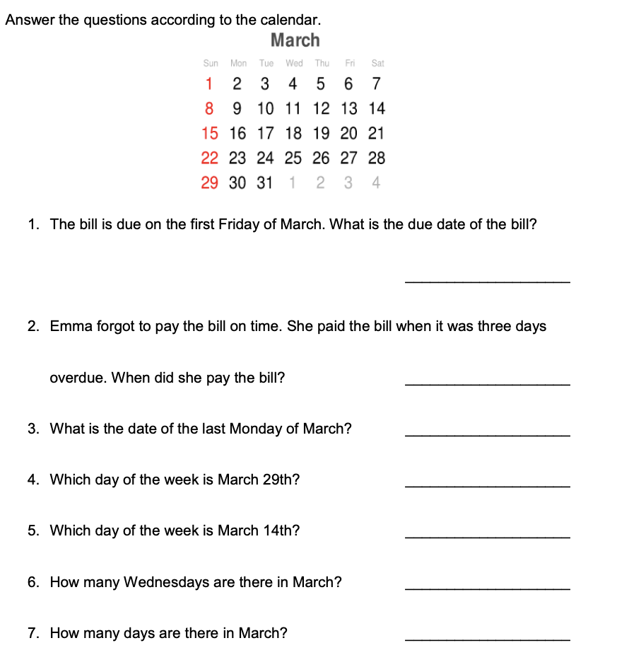
二．日历。 Please answer in Chinese: (2 points each, 2x7=14 points in total)

三、Write the time in Chinese (2 points each, 2x16=32 points in total)
