才(cái) vs. 就 （jiù）
Just：

才 indicates that the speaker feels that the events discussed happened later than expected. Sometimes it also expresses anxiety, impatience, anger, or other related emotions.
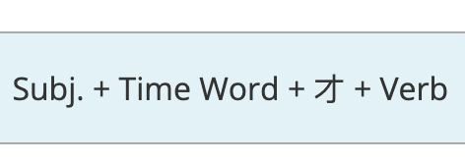

就 indicates that something has occurred earlier than the speaker expected. There may be an accompanying feeling of surprise or amazement.
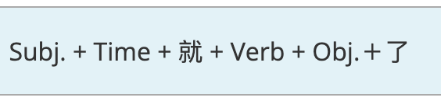

Translation:
- 她四十岁才上大学。______________________
- 她十四岁就上大学了！_____________________

- 他早上两点才睡觉！_____________________
- 他晚上八点就睡觉了！____________________

