中文考试 – 爱好
你的英文姓名：
你的中文姓名：
score: / 5

一、你有什么爱好？ （2 points for each one, 10 in total）
1. 我喜欢 （play basketball）_____________。
2. 我喜欢 （skiing）_____________。
3. 我喜欢 （singing）_____________。
4. 我喜欢 （play soccer）_____________。
5. 我喜欢 （play piano）_____________。
Choose from the list, and write the correct one.
- 拉小提琴
- 弹钢琴
- 画画
- 滑雪
- 唱歌
- 踢足球
- 打篮球
- 跑步
- 听音乐
二。 Reading comprehension: (2 point for each one, 30 in total)
你好，我叫小王。我十三岁。我是美国人。我喜欢吃草莓和梨子。我家有六口人，爸爸、妈妈、哥哥、姐姐、弟弟和我。我的爸爸喜欢跑步。我的妈妈喜欢画画。我的哥哥喜欢踢足球，我的姐姐喜欢看书。我的弟弟喜欢游泳。我不喜欢运动，我喜欢吃。
Please answer:
- How old is 小王？_____________。
- What are his favorite fruits? _____________。
- How many people are there in his family? _____________。
- Does he have a younger sister? _____________。
- What is his dad’s favorite activity? _____________。
- What is his mom’s favorite activity? _____________。
- What is his younger brother’s favorite activity? _____________。
- What is his older sister’s favorite activity? _____________。
- Does he like any sports? _____________。
- What is his favorite activity? _____________。

我有三个朋友，他们是Alex, Amy, 和Brian. Alex 喜欢滑冰，Amy 喜欢看书， Brian 喜欢跳舞。我不喜欢滑冰、看书和跳舞，我喜欢拉小提琴！

1. How many friends do I have? _____________。
2. What does Alex like to do? _____________。
3. What does Amy like to do? _____________。
4. What does Brian like to do? _____________。
5. What do I like to do? _____________。

三：Please read the dialogue below and answer questions.5 questions, 2 point for each, 10 points in total.
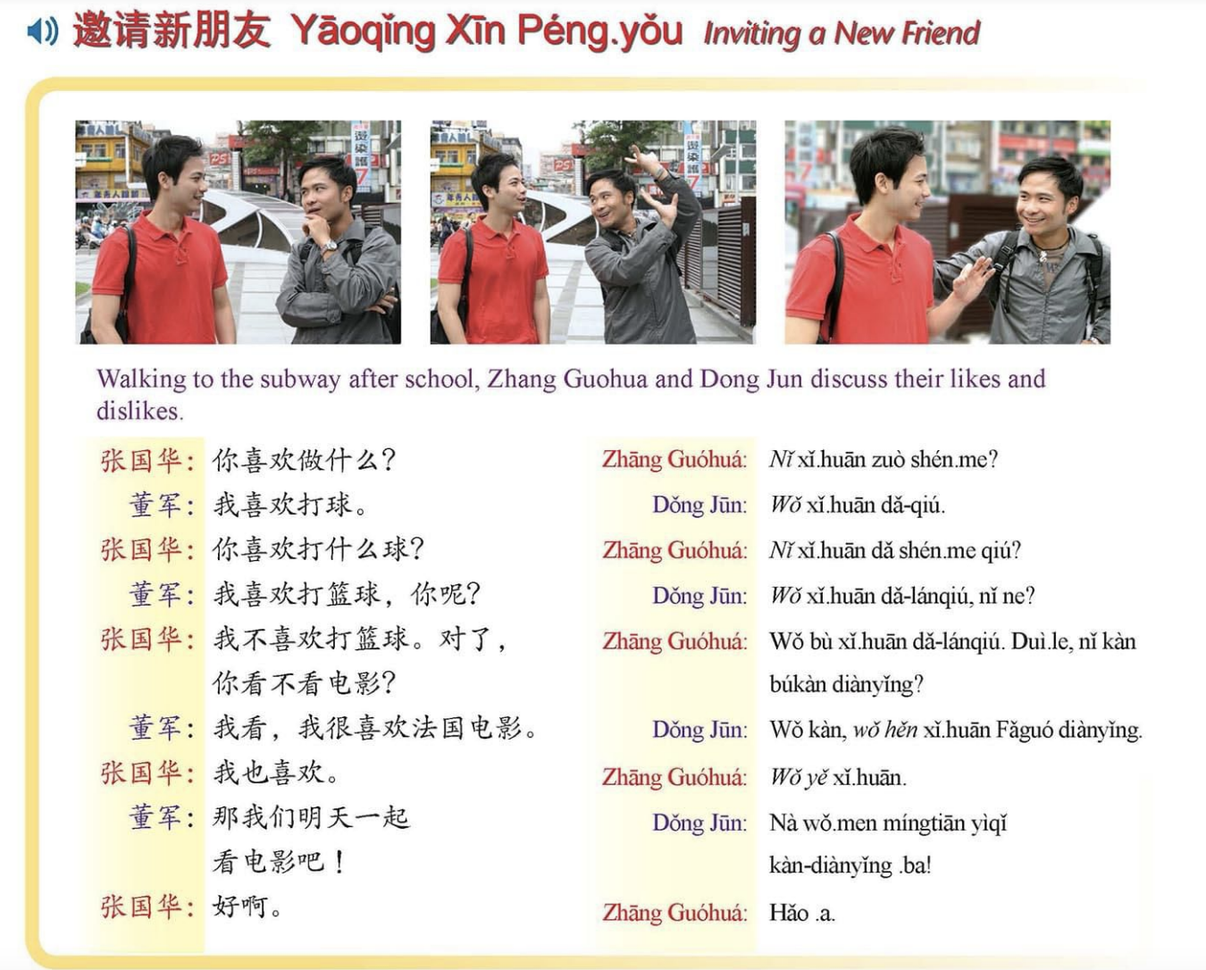

Questions:
1. How many people are there in the conversation? _____________。
2. Dongjun’s favorite sport is? _____________。
3.Ture or false: Zhang Guo Hua likes basketball a lot: _____________。
4. Ture or false: They both like swimming a lot. _____________。
5. What activity do they both enjoy? _____________。

