从来 (cónglái) + 没有 (méiyǒu)

"To Have Never Done"
Subj. + 从来 + 没(有) + Verb + 过
你 从来 没有 想 过 这 个 问题 吗？
Nǐ cónglái méiyǒu xiǎng guo zhège wèntí ma?
Have you never thought about this question?

她 从来 没 见 过 她 妈妈。
Tā cónglái méi jiàn guo tā māma.
She has never met her mother.

我 从没 学 过 这 个 词。来 has been omitted here.
Wǒ cóngméi xué guo zhège cí.
I have never before studied this word.

你们 从来 没有 听说 过 这 个 地方 吗？
Nǐmen cónglái méiyǒu tīngshuō guo zhège dìfang ma?
Have you never heard about this place before?

很 多 中国人 从来 没 出 过 国。
Hěn duō Zhōngguó rén cónglái méi chū guo guó.
A lot of Chinese people have never been abroad.

我从来没去过：
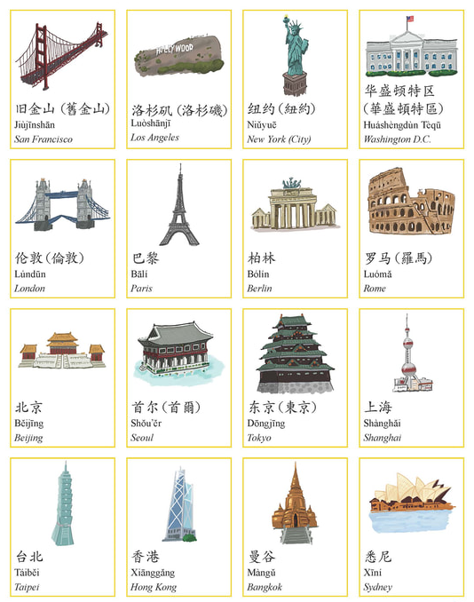

Quizlet to places: https://quizlet.com/_86qnmv?x=1jqt&i=urbqv

